**ELEC-E7250 - Laboratory Course in Communications Engineering**

Measurement report: Path loss measurements

Group members: Xingji Chen and Zheyuan Liu

1. **Commercial radio signals bandwidth and power measurements: WLAN and Bluetooth**
2. **WLAN**

* Make notes about the spectrum behavior

The spectral characteristics of the WLAN signal are within the commonly used 2.4 GHz ISM band for Wi-Fi communications. The center frequency is set at 2.450 GHz, which falls within the range of the 2.4 GHz ISM band, a range typically used for WLAN signals. The span, indicating the range of frequencies displayed, is 100 MHz, covering from 2.400 GHz to 2.500 GHz. The spectrum shows a lot of activity within the channel. A large, continuous area of red and yellow indicates a strong and possibly continuous transmission, originating from the WLAN signal. Multiple peaks and varying signal strengths suggest the presence of multiple signal sources or sources of interference within the same frequency span.

* Measure the used channel bandwidth

The channel bandwidth is 22 MHz.

* Measures the signal power in the used channel.

The signal power is -42.34 dBm.

* Save the screenshot in spectrum analyzer.

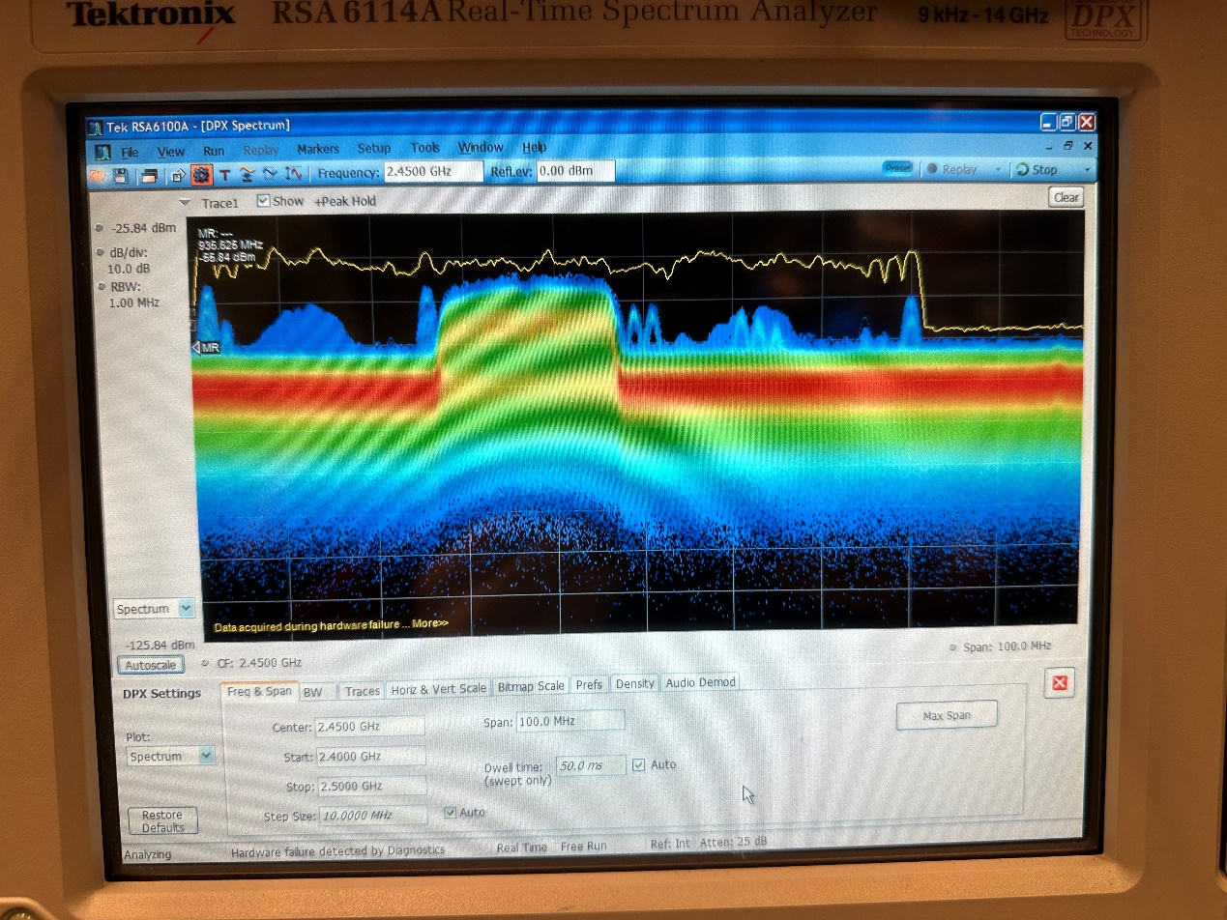

1. **Bluetooth**

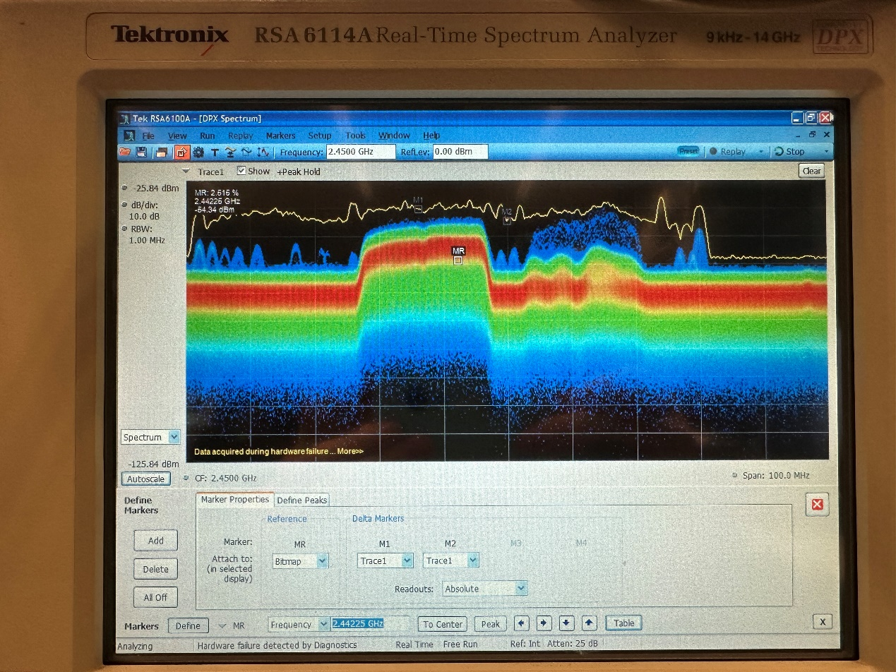

1. **Post measurements questions**

* Explain the screenshots taken and observations you made (bandwidth, spectrum shape, power etc.). Do this match with the preliminary exercise results? If not, why?

The center frequency of the WLAN spectrum is 2.450 GHz, located in the middle of the 2.4 GHz ISM band. The signal shape exhibits significant peaks and a dense presence of signals, with the highest peaks reaching about -42.34 dBm. The spectrum displays a large concentration of energy in specific parts, characteristic of WLAN channels that are actively transmitting data.

The Bluetooth spectrum is around 2.42275 GHz, also within the 2.4 GHz ISM band, a common frequency for Bluetooth communications. Bluetooth typically employs frequency-hopping spread spectrum technology, which is why the display shows a dispersed set of peaks rather than a single concentrated bandwidth.

Due to the higher data rate requirements of WLAN, its signals usually have a wider bandwidth than Bluetooth. This should be evident on the spectrum with a broader extension for WLAN. WLAN signals tend to show a more concentrated energy distribution in active channels, while Bluetooth, due to its frequency hopping, presents a more scattered collection of peaks across the spectrum. WLAN signals might have higher power peaks to cover larger areas, in contrast to Bluetooth, which is designed for short-range communication. This aligns with the results of the preliminary exercise.

* How is it possible that WLAN and Bluetooth operate on the same frequency band simultaneously?

WLAN (Wireless Local Area Network) and Bluetooth both operate in the 2.4 GHz ISM (Industrial, Scientific, and Medical) band because it is a globally available and unlicensed spectrum, allowing for widespread use without the need to purchase spectrum licenses. However, operating on the same frequency band can lead to potential interference, which both technologies mitigate using different methods.

Bluetooth reduces interference through FHSS (Frequency Hopping Spread Spectrum). This method involves rapidly switching frequencies during transmission, following a pseudorandom sequence known to both the transmitter and receiver. This minimizes the chance of interference with WLAN signals since Bluetooth occupies a specific frequency for only a brief period before hopping to the next one.

WLAN technologies such as Wi-Fi spread data across multiple frequencies within the 2.4 GHz band using DSSS (Direct Sequence Spread Spectrum) in the 802.11b standard and OFDM (Orthogonal Frequency-Division Multiplexing) in the 802.11a/g/n/ac standards. OFDM, in particular, uses multiple sub-carrier frequencies to transmit data simultaneously, aiding in effective interference management. Wi-Fi typically operates on predefined channels within the 2.4 GHz band. By choosing non-overlapping channels, Wi-Fi devices can minimize interference with each other and with other technologies such as Bluetooth.

Bluetooth usually transmits at lower power levels than WLAN, which limits the range of Bluetooth devices and reduces the potential for interference with WLAN signals that may be transmitted at higher power for greater coverage. Bluetooth can also adapt its frequency hopping pattern to avoid channels used by other technologies. By detecting which channels are occupied, Bluetooth can exclude those from its hopping pattern, thus reducing interference.

* What happened to the speedtest when they were operating simultaneously, how the spectrum looked like?

When WLAN and Bluetooth devices operate simultaneously on the same frequency band, they can interfere with each other, impacting the performance of both, depending on how close the devices are and the strength of their signals. Both WLAN and Bluetooth may experience increased latency due to retransmissions caused by packet loss or errors. The data transfer rate on WLAN could decrease because interference might corrupt data packets, necessitating their retransmission. The stability of WLAN and Bluetooth connections may also be compromised, increasing the likelihood of disconnections or reduced connection quality.

The spectrum would show higher signal density throughout the 2.4 GHz band, with overlapping transmissions from WLAN and Bluetooth devices. If Bluetooth is actively frequency hopping, transient spikes would appear on the spectrum where Bluetooth transmission occurs. The overall noise floor of the spectrum could be higher due to the increased signal activity, potentially masking weaker signals and complicating the distinction between individual transmissions. The shape of the WLAN signal might exhibit irregularities or distortions due to interference from the Bluetooth signal, especially if both are transmitting at high power or are in close proximity.

* Did you ﬁnd anything surprising?

Two different wireless communication technologies can operate within the same frequency band without causing continuous significant interference issues. The advanced techniques used to reduce interference, such as frequency hopping and channel avoidance, are surprisingly effective. The dynamic nature of spectrum sharing and how these technologies dynamically adjust their behavior to coexist, such as Bluetooth avoiding channels that WLAN is using, is noteworthy.

1. **Commercial radio signals bandwidth and power measurements: Mobile networks and FM radio**
2. **GSM**

* Measure the bandwidth of the signal in the channel

The bandwidth is 251 kHz.

* Measure the power of the signal in that channel.

The signal power is -40.53 dBm.

* Save the screenshot.

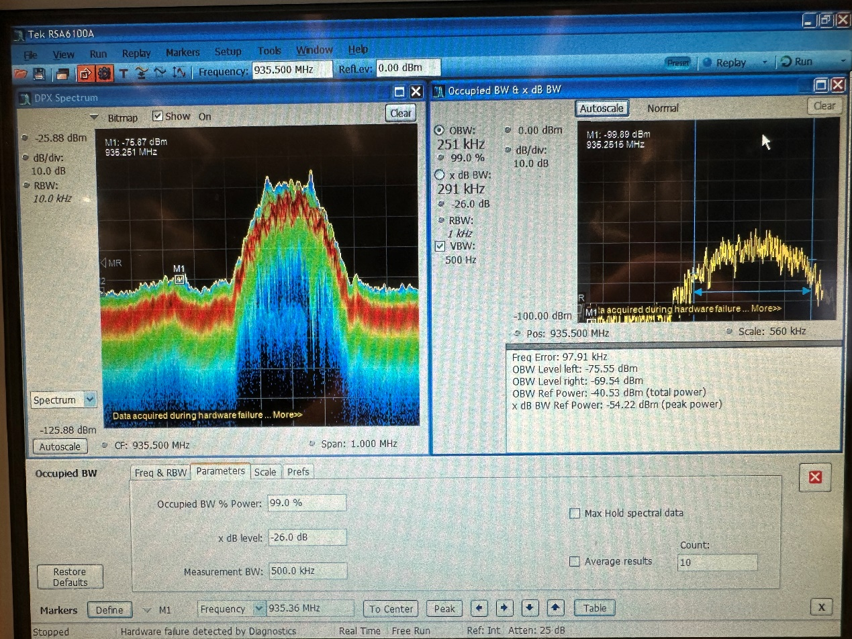

1. **LTE**

**Downlink:**

* Measure the bandwidth of the signal in the channel

The bandwidth is 10.1 MHz.

* Measure the power of the signal in that channel.

The signal power is -50.25 dBm.

* Save the screenshot.

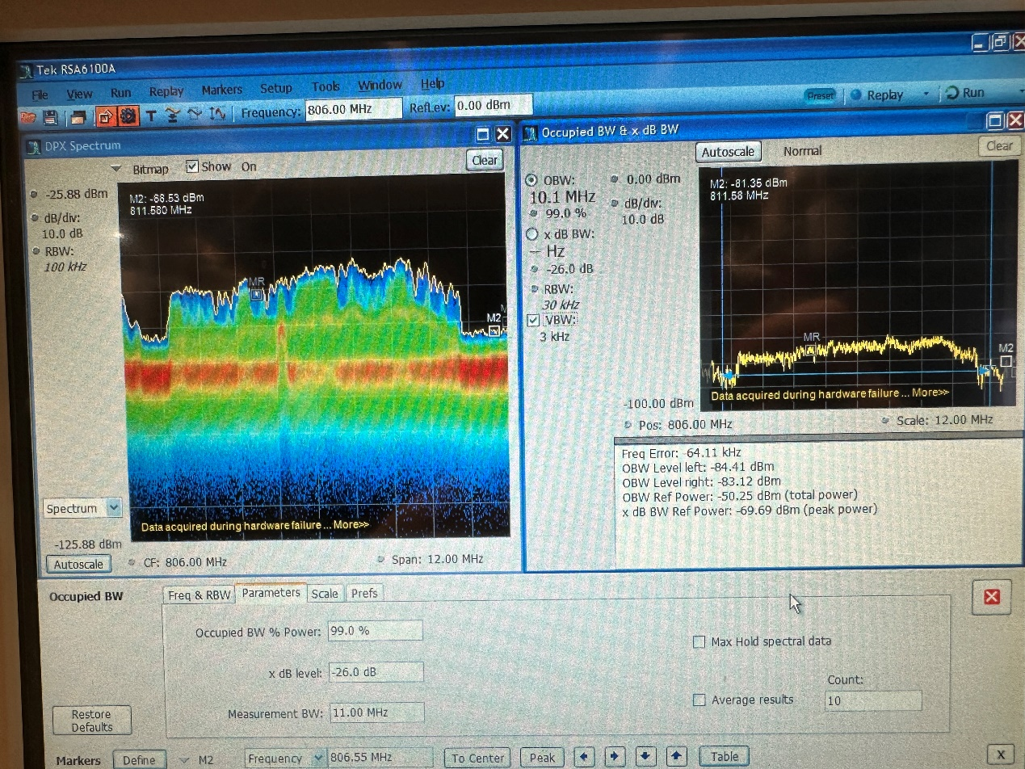

**Uplink:**

* Measure the bandwidth of the signal in the channel

The bandwidth is 469 kHz.

* Measure the power of the signal in that channel.

The signal power is -49.91 dBm.

* Save the screenshot.

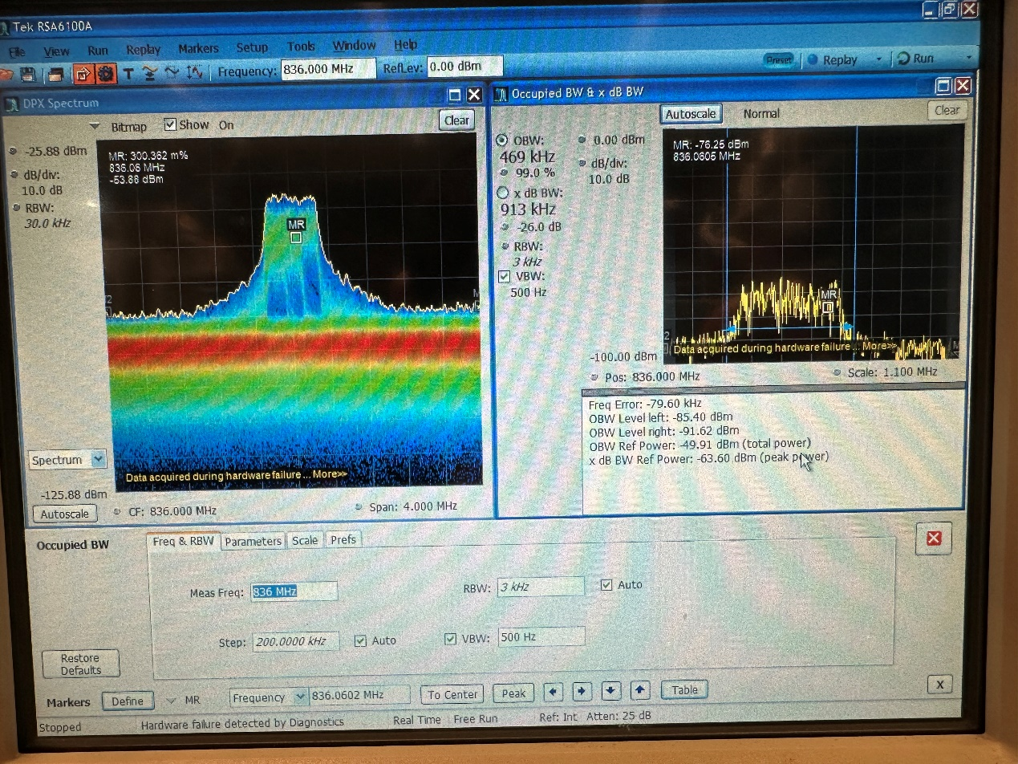

1. **FM**

In this part, after starting gqrx program for listening the radio and loading the config for lab2FmWhole.conf, we could analyze the FM signal spectrum. Changing the central spectrum to 94.89 MHz, we could find a peak here, at this time, there is voice in the channel

In this figure, we could see seven channel peaks. And the max frequency is 94.89MHz.

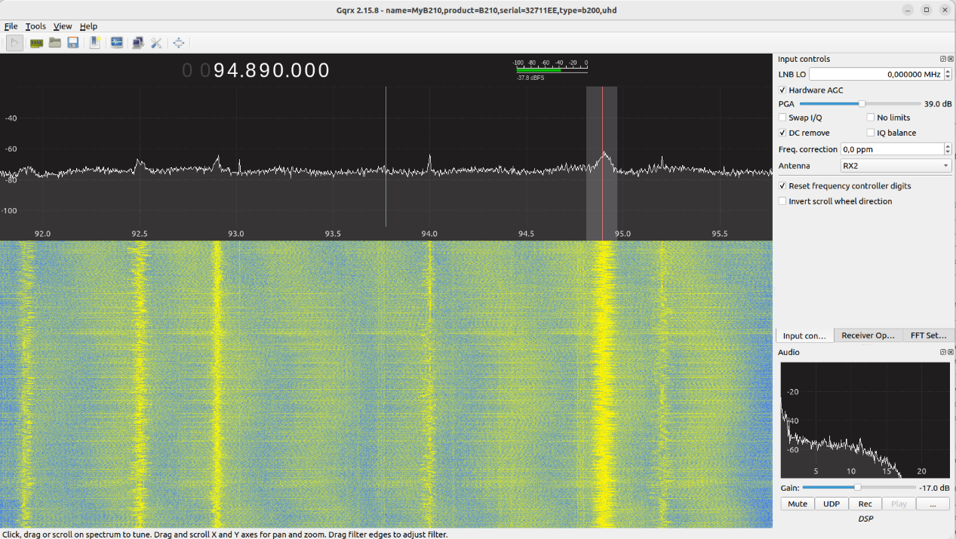

The second figure is screenshotted when the channel is silent. The max frequency is also 94.89MHz.

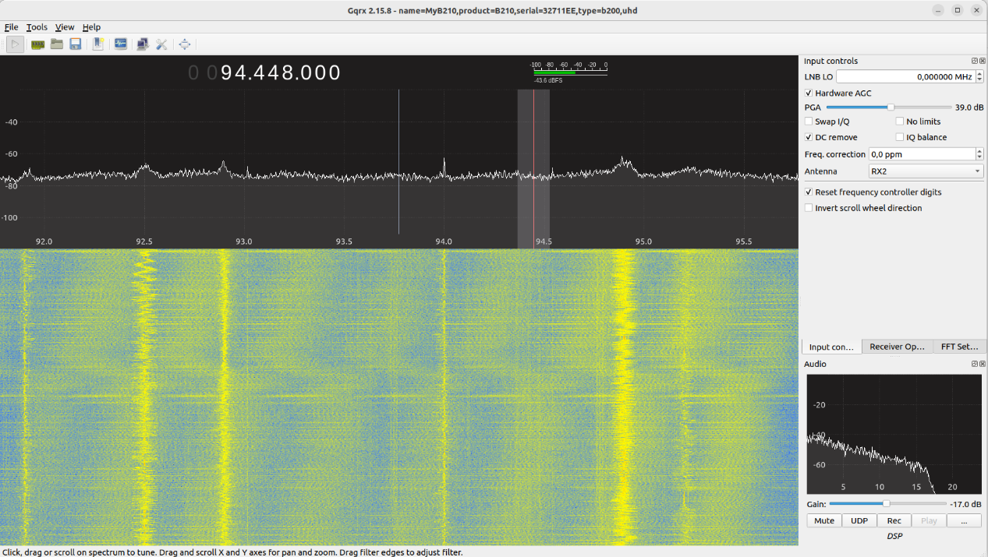

1. **Post measurements questions**

(31) By observing the screenshots we got from the experiment, we could see that the result is basically match the preliminary exercise results.

(32) According the second figure in the FM part, the max frequency is 94.89MHz.

(33) The most significant factor is the difference in power levels between the uplink and downlink. The downlink, which is the transmission from the base station to the mobile device, typically operates at a much higher power level than the uplink. This is because base stations are equipped with more powerful transmitters and better antennas. On the other hand, the uplink, which is the transmission from the mobile device to the base station, operates at lower power to conserve the mobile device's battery and to minimize interference with other devices.

Uplink signals are more susceptible to interference and noise since they are transmitted at lower power. This can also make the uplink spectrum appear weaker or more cluttered in a spectrum analysis.

(34) For 3G measurement, by the permission of the teaching assistant, we skip this part as the 3G services are nearly replaced by 4G and 5G now.

(35) Same as (34).

(36) In LTE (Long-Term Evolution) networks, the uplink signal often does not cover the entire bandwidth due to several factors related to the technology's design and the nature of wireless communications. The reasons are as follows,

LTE uses a flexible bandwidth allocation mechanism. The amount of bandwidth allocated to each user in the uplink is dynamically adjusted based on demand and network conditions. In many cases, not all users require or are allocated the full bandwidth. For example, if a user is only sending small amounts of data (like texts or small emails), the network allocates only a portion of the available bandwidth to that user.

LTE uplink uses SC-FDMA technology. Unlike the downlink, which uses OFDMA (Orthogonal Frequency Division Multiple Access), SC-FDMA is less prone to high Peak-to-Average Power Ratio (PAPR) issues. This characteristic allows more efficient power usage but also means that the uplink signal might not spread across the entire available bandwidth, as SC-FDMA inherently concentrates energy in a narrower band compared to OFDMA.

(37) In LTE (Long-Term Evolution) networks, multiple users share the same bandwidth through a combination of advanced multiplexing techniques. The two primary methods are:

Orthogonal Frequency Division Multiple Access (OFDMA) for Downlink:

Frequency Division: In OFDMA, the available bandwidth is divided into many narrowband subcarriers. Each subcarrier can be independently modulated and assigned to different users. This allows multiple users to transmit simultaneously but on different frequencies within the overall bandwidth.

Orthogonality: The key feature of OFDMA is the orthogonality of subcarriers, which means they are mathematically arranged in such a way as to prevent interference between them. This increases the efficiency of spectrum usage.

Dynamic Allocation: The network dynamically allocates subcarriers to users based on their data requirements and channel conditions. Users with higher data demands or better channel conditions might be allocated more subcarriers.

Single Carrier Frequency Division Multiple Access (SC-FDMA) for Uplink:

Single Carrier: Unlike OFDMA, SC-FDMA uses a single carrier for each user. It is similar to OFDMA in dividing the bandwidth into subcarriers, but it employs a different technique for modulating data onto these subcarriers.

Lower Peak-to-Average Power Ratio (PAPR): SC-FDMA is chosen for the uplink primarily because it has a lower PAPR compared to OFDMA. This makes it more power-efficient, which is crucial for battery-operated mobile devices.

Resource Block Allocation: Like in the downlink, the network dynamically allocates resource blocks (group of subcarriers) to different users based on their data needs and channel conditions.

(38) In many cellular network technologies, including LTE, it's common for uplink transmissions (from the mobile device to the base station) to use lower frequencies compared to downlink transmissions (from the base station to the mobile device). There are several practical and technical reasons for this arrangement:

Propagation Characteristics: Lower frequencies generally have better propagation characteristics – they can travel longer distances and penetrate obstacles more effectively. This is advantageous for uplink signals, which are transmitted from mobile devices that have less power and smaller antennas compared to base stations.

Power Efficiency: Mobile devices are limited in their power output to conserve battery life. Lower frequencies are more energy-efficient for transmission, which is crucial for mobile devices that operate on battery power.

Reduced Interference: Lower frequency bands tend to have less interference, which is beneficial for uplink transmissions as they originate from a wide variety of locations and conditions, often in environments with a high potential for interference.

Antenna Size and Design: Lower frequencies require larger antennas for optimal performance. While base stations can accommodate large antennas (necessary for the higher-frequency downlink), mobile devices need smaller antennas that are more suited to the lower frequencies used for uplink.

Spectrum Allocation and Regulations: Radio frequency spectrum is a regulated resource, and the allocation is governed by international and national bodies. Historically, lower frequency bands were among the first to be allocated for mobile communications, and these bands have been traditionally used for uplink due to their favorable propagation characteristics.

Network Planning and Capacity Management: Separating uplink and downlink frequencies helps in network planning and management. Different frequencies can have different cell sizes and coverage areas, which can be strategically used to optimize network capacity and performance.

1. **Path loss measurement**
2. **Calibration**

For the first part of the section 4, we need to record the gain we had to set in Gnuradio program to achieve this signal level (which is -40 dB): for both receivers at both frequencies (2.46GHz and 5.8GHz).

The results we record are as follows:

|  |  |  |
| --- | --- | --- |
|  | RX1 | RX2 |
| 2.46GHz | 27 dB | 30 dB |
| 5.8GHz | 31 dB | 43 dB |

The measurement windows include:

Time-Frequency: Focus on a narrower frequency band, as indicated by the orange vertical line which may represent a specific frequency of interest or a center frequency around which measurements are being taken.

The second window, labeled "Summed time," is not displaying any visible data for 'Signal 1' and 'Signal 2'. It intended to show the amplify of signals over time, but it is currently empty.

The third and fourth windows are labeled "RX1" and "RX2", respectively. These are showing the received signal strength indicator (RSSI) measurements for two different receivers or channels, over a frequency band. These plots are commonly used in radio frequency (RF) analysis to evaluate the power present in a received radio signal, which can be important for determining the quality of the signal reception.

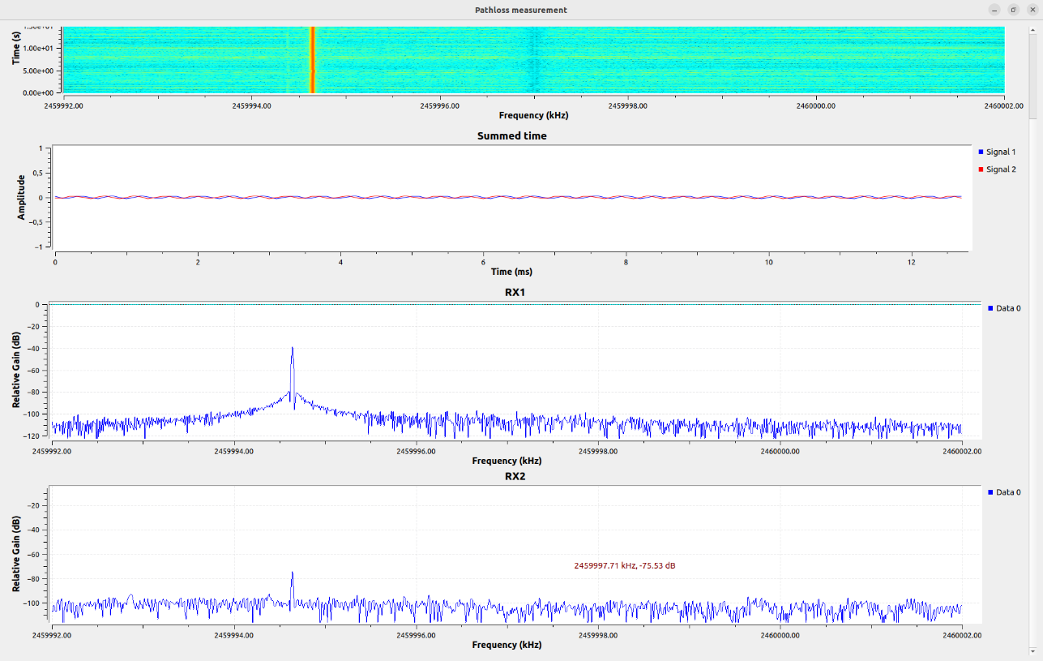

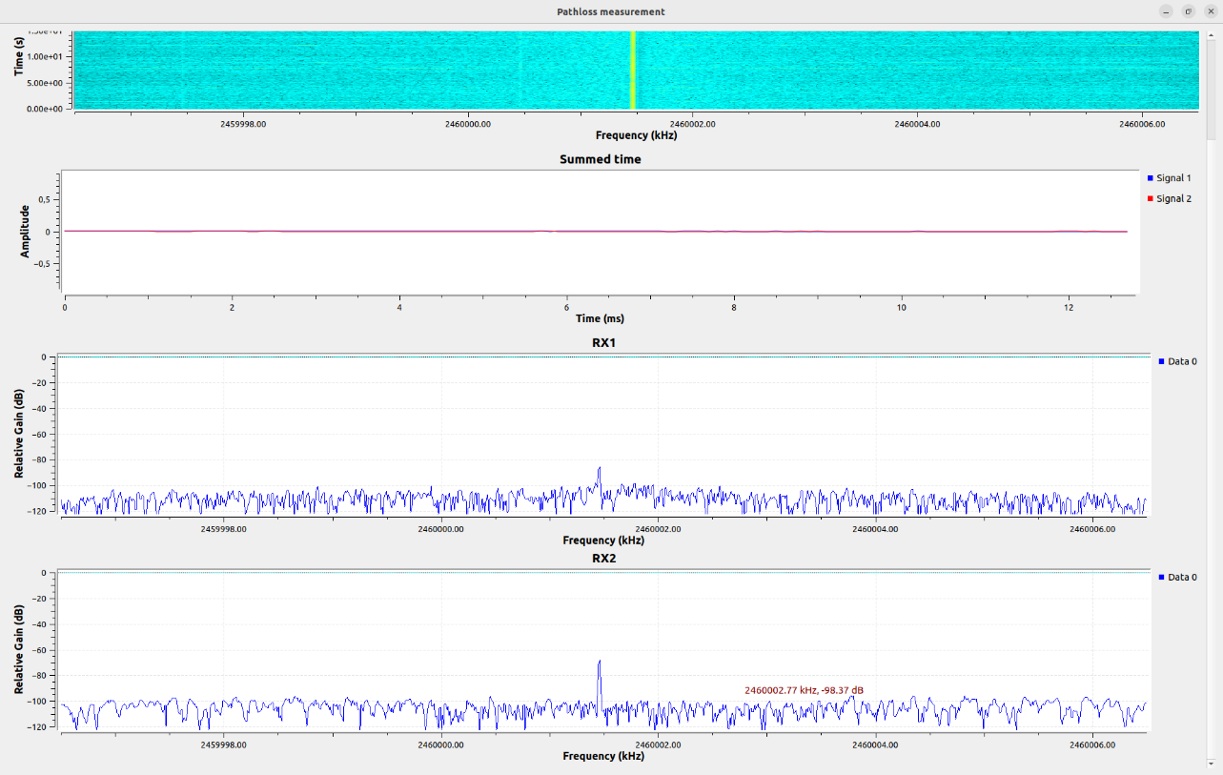

1. **Hallway measurement**

Test the path loss like:

图形用户界面

The output of 2.46GHz is like:

The output of 5.8GHz is like:

As we didn’t save the csv file and the file pathloss.m, We analyze the results get from lab.

According to the figure, we could see both fast fading and slow fading, in small period of time, we could see that the line shaking and change rapidly, and in a long term we could see the trend of the curve changing slowly.

The short distance between the transfer and receiver may cause the reflection of the signal. cause the fast fading. As the moving of the transfer, the obstacles such as the door of the lab and the chair in lab may cause the slow fading.

By observing the two figures, for 2.46GHz, the average signal power of antenna 1 is about -80dB, antenna 2 is about -90dB. For 5.8GHz, the average signal power of both antenna 1 and antenna 2 are about -85dB.

For the location of our antennas, we were at the position RX3 in the picture hence the values of pathloss maybe lower than the other groups, as we sit near the door.